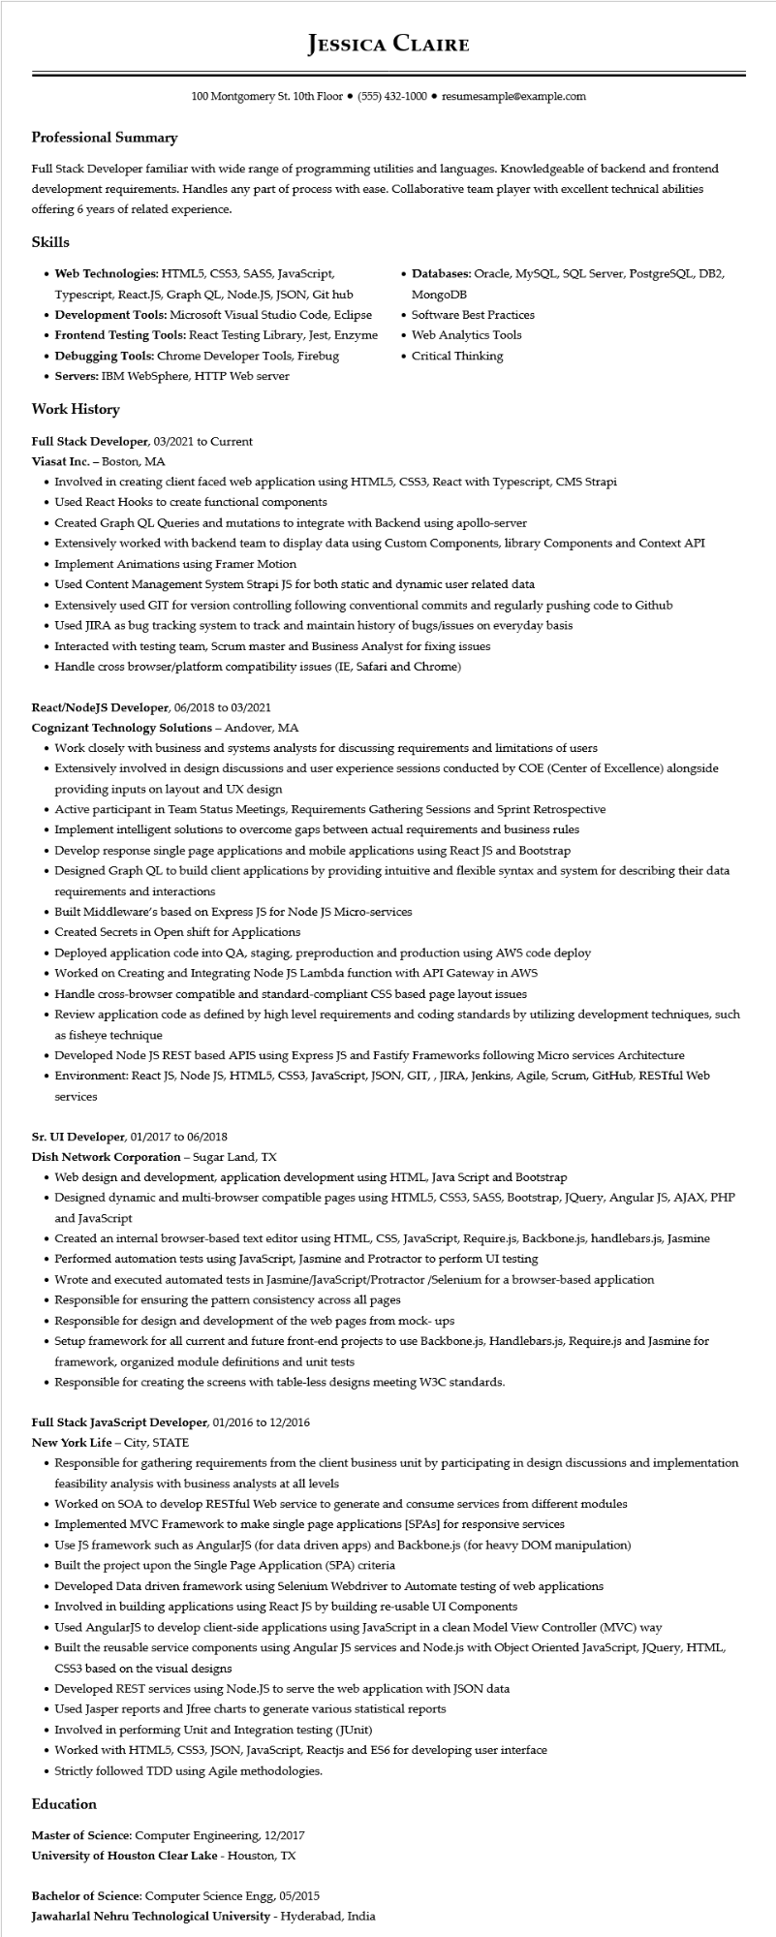
Professional Summary
JESSICA CLAIRE
100 Montgomery St. 10th Floor (555) 432-1000⚫ resumesample@example.com
Full Stack Developer familiar with wide range of programming utilities and languages. Knowledgeable of backend and frontend development requirements. Handles any part of process with ease. Collaborative team player with excellent technical abilities offering 6 years of related experience.
Skills
• Web Technologies: HTML5, CSS3, SASS, JavaScript, Typescript, React.JS, Graph QL, Node.JS, JSON, Git hub
• Development Tools: Microsoft Visual Studio Code, Eclipse • Frontend Testing Tools: React Testing Library, Jest, Enzyme • Debugging Tools: Chrome Developer Tools, Firebug
• Servers: IBM WebSphere, HTTP Web server
Work History
Full Stack Developer, 03/2021 to Current
Viasat Inc. - Boston, MA
• Databases: Oracle, MySQL, SQL Server, PostgreSQL, DB2, MongoDB
• Software Best Practices
• Web Analytics Tools • Critical Thinking
• Involved in creating client faced web application using HTML5, CSS3, React with Typescript, CMS Strapi
• Used React Hooks to create functional components
• Created Graph QL Queries and mutations to integrate with Backend using apollo-server
• Extensively worked with backend team to display data using Custom Components, library Components and Context API • Implement Animations using Framer Motion
• Used Content Management System Strapi JS for both static and dynamic user related data
• Extensively used GIT for version controlling following conventional commits and regularly pushing code to Github
• Used JIRA as bug tracking system to track and maintain history of bugs/issues on everyday basis
• Interacted with testing team, Scrum master and Business Analyst for fixing issues
• Handle cross browser/platform compatibility issues (IE, Safari and Chrome)
React/NodeJS Developer, 06/2018 to 03/2021
Cognizant Technology Solutions - Andover, MA
• Work closely with business and systems analysts for discussing requirements and limitations of users
• Extensively involved in design discussions and user experience sessions conducted by COE (Center of Excellence) alongside providing inputs on layout and UX design
• Active participant in Team Status Meetings, Requirements Gathering Sessions and Sprint Retrospective
• Implement intelligent solutions to overcome gaps between actual requirements and business rules
• Develop response single page applications and mobile applications using React JS and Bootstrap
• Designed Graph QL to build client applications by providing intuitive and flexible syntax and system for describing their data requirements and interactions
• Built Middleware's based on Express JS for Node JS Micro-services
• Created Secrets in Open shift for Applications
• Deployed application code into QA, staging, preproduction and production using AWS code deploy
• Worked on Creating and Integrating Node JS Lambda function with API Gateway in AWS
• Handle cross-browser compatible and standard-compliant CSS based page layout issues
• Review application code as defined by high level requirements and coding standards by utilizing development techniques, such as fisheye technique
• Developed Node JS REST based APIS using Express JS and Fastify Frameworks following Micro services Architecture
• Environment: React JS, Node JS, HTML5, CSS3, JavaScript, JSON, GIT,, JIRA, Jenkins, Agile, Scrum, GitHub, RESTful Web services
Sr. UI Developer, 01/2017 to 06/2018
Dish Network Corporation - Sugar Land, TX
• Web design and development, application development using HTML, Java Script and Bootstrap
• Designed dynamic and multi-browser compatible pages using HTML5, CSS3, SASS, Bootstrap, JQuery, Angular JS, AJAX, PHP and JavaScript
• Created an internal browser-based text editor using HTML, CSS, JavaScript, Require.js, Backbone.js, handlebars.js, Jasmine
• Performed automation tests using JavaScript, Jasmine and Protractor to perform UI testing
• Wrote and executed automated tests in Jasmine/JavaScript/Protractor /Selenium for a browser-based application
• Responsible for ensuring the pattern consistency across all pages
• Responsible for design and development of the web pages from mock-ups
• Setup framework for all current and future front-end projects to use Backbone.js, Handlebars.js, Require.js and Jasmine for framework, organized module definitions and unit tests
• Responsible for creating the screens with table-less designs meeting W3C standards.
Full Stack JavaScript Developer, 01/2016 to 12/2016
New York Life - City, STATE
• Responsible for gathering requirements from the client business unit by participating in design discussions and implementation feasibility analysis with business analysts at all levels
• Worked on SOA to develop RESTful Web service to generate and consume services from different modules
• Implemented MVC Framework to make single page applications [SPAs] for responsive services
• Use JS framework such as AngularJS (for data driven apps) and Backbone.js (for heavy DOM manipulation)
• Built the project upon the Single Page Application (SPA) criteria
• Developed Data driven framework using Selenium Webdriver to Automate testing of web applications
• Involved in building applications using React JS by building re-usable UI Components
• Used AngularJS to develop client-side applications using JavaScript in a clean Model View Controller (MVC) way
• Built the reusable service components using Angular JS services and Node.js with Object Oriented JavaScript, JQuery, HTML, CSS3 based on the visual designs
• Developed REST services using Node.JS to serve the web application with JSON data
• Used Jasper reports and Jfree charts to generate various statistical reports
• Involved in performing Unit and Integration testing (JUnit)
• Worked with HTML5, CSS3, JSON, JavaScript, Reactjs and ES6 for developing user interface
• Strictly followed TDD using Agile methodologies.
Education
Master of Science: Computer Engineering, 12/2017 University of Houston Clear Lake - Houston, TX
Bachelor of Science: Computer Science Engg, 05/2015
Jawaharlal Nehru Technological University - Hyderabad, India

